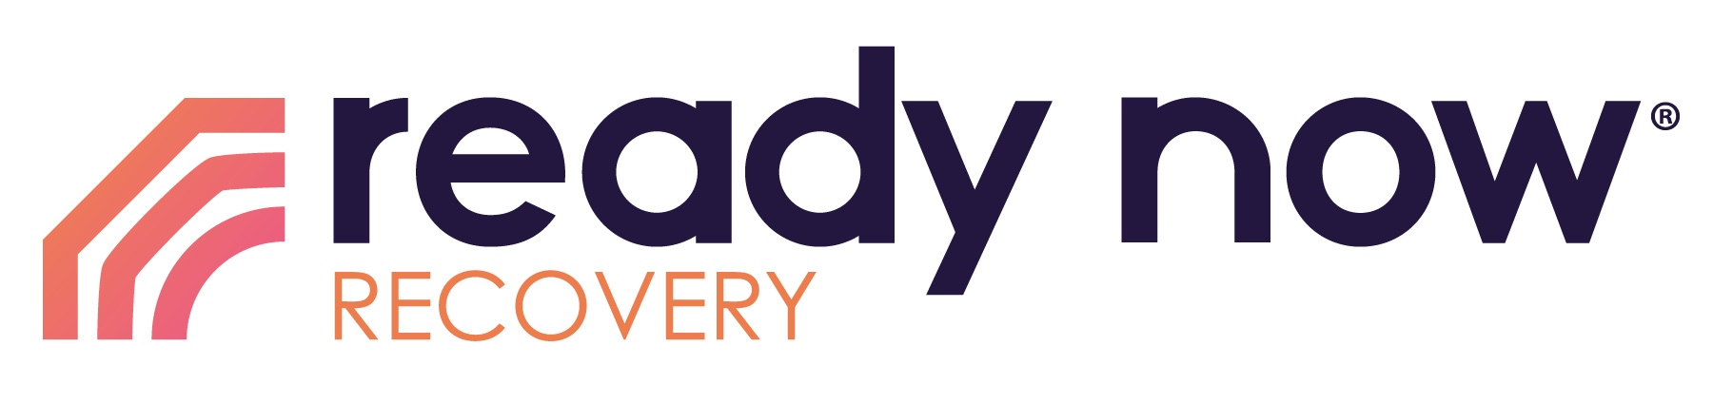

Thank you for taking the time to attend the Ready Now Recovery Community Presentation. We believe that you attended because you are aware of the growing need for resources, for those who struggle with addictions and other life-controlling issues, within your community. If you would like more information, interested in becoming a partner, and/or are interested in becoming a trained Ready Now Recovery Facilitator, please contact us at https://readynow.org.
We look forward to assisting you as a community leader and volunteer. Ready Now Recovery wants to provide education, resources, and support to encourage healthy community options. Please contact us with any questions you may have.

(Thank you or sincerely)

(CER name)
(CER Email & Phone number)

